**AIR RESERVATION SYSTEM**

Project Team No-17

Name- Srinija Katikineni,

Student id-1004775

**ABSTRACT**

* The database represents each Airport by a unique Airport Code, the Airport City Name, and the City and the State in which the Airport is located.
* Each airline flight has a unique number and the name of the Airline that runs the flight.
* A flight is composed of one or more flight legs. Each flight leg has a leg number, Departure Airport and Scheduled Departure Time, and an arrival airport and Scheduled Arrival Time.
* The Passenger reserves Seats in the flights which has a unique seat numbers and details of the passenger name and passenger contact Known as PNR(Passenger Name Record).
* Flight contains Employees with a unique identity number and name of the employee and the Employees are categorized into Flight attendants who attend the for serve the customers and Flight Engineers and Pilot.

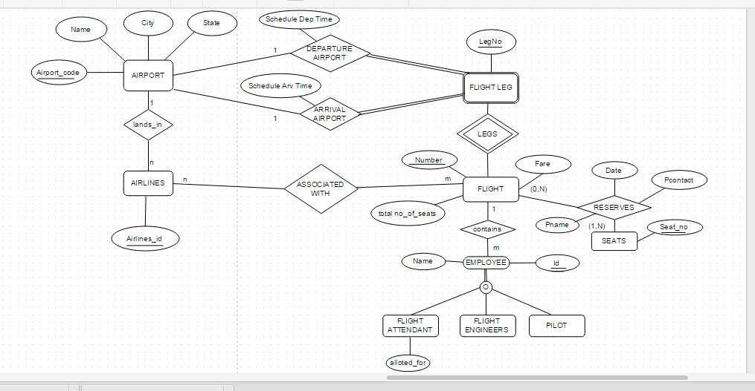

**ER DIAGRAM**

**RELATIONAL SCHEMA FOR AIR RESERVATION SYSTEM:**

|  |
| --- |
| **AIRPORT** |
| Airport_code(PK)  Name  City  State |

|  |
| --- |
| **AIRLINES** |
| Airline_id (PK)  Airport_code (FK)  Flight_number |

|  |
| --- |
| **FLIGHT** |
| Flight_number(PK)  Airline_id (FK)  Airport_code (FK)  Flight_fare  Total_number_of_seats |

|  |
| --- |
| **SEAT RESERVATION** |
| Flight_number (FK)  Leg_number(FK)  Date  Seat_number (PK)  Passenger_name  Passenger_phone |

|  |
| --- |
| **FLIGHT_LEG** |
| Flight_number (FK)  Leg_number (PK)  Departure_airport_code  Scheduled_departure_time  Arrival_airport_code  Scheduled_arrival_time |

|  |
| --- |
| **EMPLOYEE** |
| Flight number (FK)  Employee _id (PK)  Employee_name |

|  |
| --- |
| **FLIGHT_ENGINEERS** |
| Engineer_id  Flight_number  Engineer_name |

|  |
| --- |
| **PILOT** |
| Pilot_id  Flight_number  Flight_number |

|  |
| --- |
| **FLIGHT_ATTENDENT** |
| Flight_number  Employee_id  Employee_name  Flight_attendent_alloted_for |

**PRIMARY AND FOREIGN KEYS**::

Airport_code: It is the primary key of AIRPORT. It is unique for each and every airport. It acts as foreign key for AIRLINES.

Airline_id: It is the primary key for AIRLINES. It is unique for all Airlines and Airport code is the Foreign Key.

Flight_number: It is the primary key of FLIGHT. It is unique for every Flight. It acts as a foreign key for FLIGHT_LEG, SEAT_RESERVATION, FLIGHT_ATTENDENT and AIRLINES.

Leg_number: It is the primary key for FLIGHT_LEG. It is unique for every Flight_leg. It is a foreign key for SEAT_RESERVATION.

Seat_number: It is the primary key for SEAT_RESERVATION. It is unique for every seat.

Employee_id: It is the primary key for EMPLOYEE. IT is unique for every employee.

Engineer_id: It is the primary Key for FLIGHT_ENGINEERS. It is unique for every Engineer.

Pilot_id: It is the primary key for PILOT. It is unique for all the pilots.

**REVIEW OF PHASE2**

From the phase 2, we learnt how to draw ER diagrams and Relational schema for the Entites and attributes. The identification of primary key and foreign key. The relationships between entities like 1 to 1, 1 to N, N to M. We also learnt how to draw Enhanced Entity Relationship Model .

**MORE TO LEARN**

1. How to show Enhanced Entity relationship Diagram in Relational Schema?
2. How to use relationships of ER diagram in Relational schema ?